Village
Of
Arlington Heights
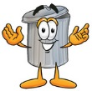

Trash & Yard waste Collection Information.

Page 1
This flyer is to inform everyone about waste collection information and rules.
Rumpke Trash Collection:
The village of Arlington Heights contracts trash collection with Rumpke and have for many years. Rumpke sets the Villages rates each year based on the number of units paying for waste removal. Apartments and multiple units get charged per apartment or unit. The use of dumpsters is optional for multiple family units and will cause an additional cost billed from Rumpke to the landlord for rental of the dumpster.
Our contract with Rumpke includes weekly curbside collection of trash. The Village asks residents to not set out waste and garbage cans until after 5:00 p.m. on Monday evening. Trash cans should be removed off the street by Tuesday afternoon. This will help keep our community clean and reduce the chance of trash being blown on streets.
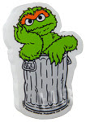
Please review the insert on placing waste out for curbside collection. Rumpke prepared it and if you follow the bundling rules Rumpke will pick up most items. There are some limits on what type of waste Rumpke will collect. These are listed on the flyer.

Village yard waste collection:
The Village will park a Yard waste trailer in your driveway to collect large amounts of yard waste (Grass, tree limbs and shrubs). We do have a site to dump this material and compost it. There is no charge for this service as this is part of your waste fee. Simply contact the Service Director through the town hall (513) 821-2076 Monday-Friday 8AM-4PM and he will schedule the Yard waste trailer for you.

Waste trailer rental:
The Village will park a waste removal trailer in your driveway to collect large amounts of waste. You may rent the trailer on a first come, first serve basis, the rental fee is $150.00 for each rental. In order to rent the trailer you must come into the office Monday-Friday 8AM-4PM to fill out a rental contract.
We cannot accept: MOTOR OIL, OLD TIRES, CAR BATTERIES, ANTIFREESE, BRAKE FLUID, PAINT, SHINGLES and HAZARDOUS SUBSTAINCES, REFRIDERATORS, AIR CONDITIONERS, AND ANY OTHER ITEMS THAT CONTAIN FREON.
Page 2
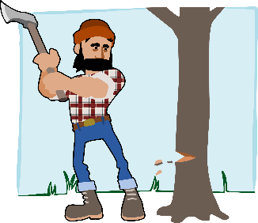
Cutting Trees:
Companies cutting down trees are required to remove the cuttings not the Village. This should be included in your agreement with tree contractors. We encourage you to bundle your yard waste so Rumpke will collect it or call and schedule the yard waste trailer.

Burning waste:
Open burning of any waste is prohibited in the Village. The only open fire should be in a manufactured coal or gas grill for cooking food. Manufactured fire pits are allowed that burn wood or gas. Failure to control the smoke from these units will cause neighbors to phone on complaints of smoke coming in windows and the Sheriff’s Department or Fire Chief will be called to investigate.

Grass cuttings:
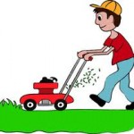
We are also asking everyone to remove grass clippings from the street after cutting grass. Grass getting in the cracks of the streets will cause weeds to grow and break the blacktop. Also grass that is left in the streets gets into the sewers and can cause drainage issues and potential flooding. Most of the problem has come from contractors cutting grass and not cleaning up after themselves.

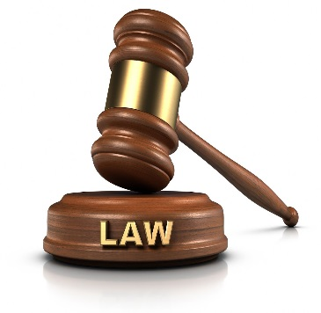
Ordinances & Laws:
Over the past two years it has become necessary to pass ordinances that fine individuals trying to bypass the rule on waste collection. It is regrettable but necessary to insure everyone is paying for services and not setting out waste in other yards so they don’t have to pay a waste bill. We also have residents moving out and leaving the street full of garbage on days Rumpke doesn’t collect and it gets blown in everyone’s yards. The Sheriff’s Department will site individuals to court for ignoring these laws.
Page 3
Rumpke and Arlington Heights
Presents
Solid Waste Guidelines

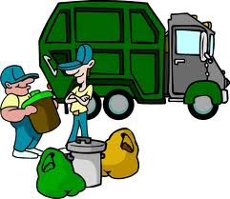
Weekly collection:
Rumpke will provide residential, solid waste collection one time a week Acceptable garbage includes ashes, rags, garden and kitchen refuse, waste paper products, scrap wood and lumber, brush (must be cut and ties in bundles not exceeding 4 feet in length), Christmas trees, household items (less than 85 pounds) and household waste. Grass clippings also are acceptable. Rumpke will pick up your garbage and recyclables after 6 a.m. on your pick up day.
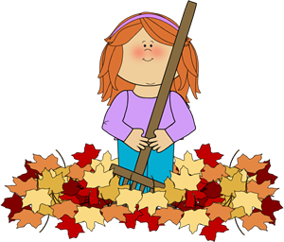
Yard waste:
Trees and limbs 3 inches or more in diameter are unacceptable. However, Rumpke will pick up other types of yard waste, such as bagged leaves and other tree and brush material. Simply place acceptable yard waste with your other refuse on your scheduled pick up day.

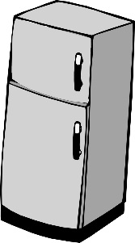
Bulk Items:
Rumpke will collect bulk items with your other garbage, call Rumpke to request a larger pick up. Bulk items include any item weighing more than 85 pounds, large furniture, and appliances (without chlorofluorocarbons- CFCs). Please do not place construction or demolition debris at the curb.

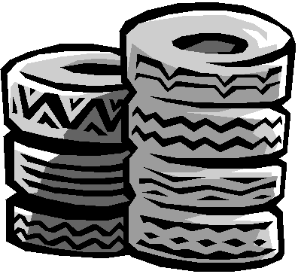
Uncollectible Wastes:
Household hazardous wastes, unquartered tires, lead acid batteries and items containing chlorofluorocarbons (CFCs) i.e., refrigerators, freezers, air conditioners or ice makers are not collectible due to EPA regulations. A local appliance recycler will dispose of items containing CFCs. Local heating and air conditioning companies can remove Freon from appliances. Once CFC removal is certified please place the item at the curb for a heavy pick up.

Holiday Schedule:
Rumpke does not provide service on Thanksgiving Day, Christmas day and New Year’s Day. All pick-up schedules falling on these holidays or after these holidays will be delayed on day during that particular week. The following week pick-up schedules will return to normal. Rumpke will provide uninterrupted services on all other holidays.

